**que02:-**

**What is OOP? List OOP concepts**

**OOPS concepts are as follows:**

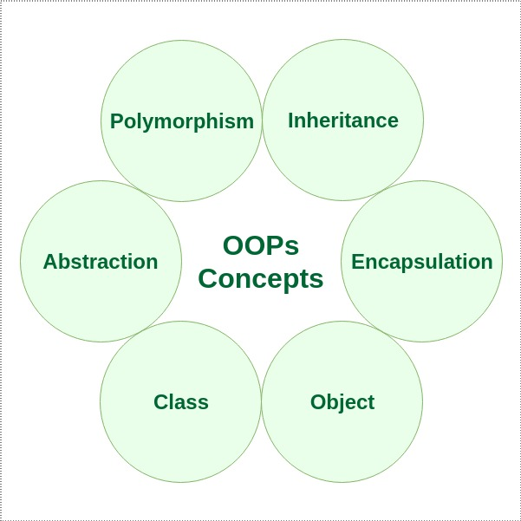

**Class:-**

A class is a user-defined blueprint or prototype from which objects are created. It represents the set of properties or methods that are common to all objects of one type. Using classes, you can create multiple objects with the same behavior instead of writing their code multiple times. This includes classes for objects occurring more than once in your code.

**Object:-**

object is a basic unit of Object-Oriented Programming that represents real-life entities. A typical Java program creates many objects, which as you know, interact by invoking methods. The objects are what perform your code, they are the part of your code visible to the viewer/user.

**Method:-**

A method is a collection of statements that perform some specific task and return the result to the caller. A method can perform some specific task without returning anything. Methods allow us to reuse the code without retyping it, which is why they are considered time savers. In Java, every method must be part of some class, which is different from languages like C, C++, and Python.

**Abstraction:-**

Data Abstraction is the property by virtue of which only the essential details are displayed to the user. The trivial or non-essential units are not displayed to the user. Ex: A car is viewed as a car rather than its individual components.

Data Abstraction may also be defined as the process of identifying only the required characteristics of an object, ignoring the irrelevant details. The properties and behaviors of an object differentiate it from other objects of similar type and also help in classifying/grouping the object.

**Encapsulation:-**

It is defined as the wrapping up of data under a single unit. It is the mechanism that binds together the code and the data it manipulates. Another way to think about encapsulation is that it is a protective shield that prevents the data from being accessed by the code outside this shield.

Technically, in encapsulation, the variables or the data in a class is hidden from any other class and can be accessed only through any member function of the class in which they are declared.

In encapsulation, the data in a class is hidden from other classes, which is similar to what data-hiding does. So, the terms “encapsulation” and “data-hiding” are used interchangeably.

Encapsulation can be achieved by declaring all the variables in a class as private and writing public methods in the class to set and get the values of the variables.

**Inheritance:-**

Inheritance is an important pillar of OOP (Object Oriented Programming). It is the mechanism in Java by which one class is allowed to inherit the features (fields and methods) of another class. We are achieving inheritance by using extends keyword. Inheritance is also known as “is-a” relationship.

**Polymorphism:-**

It refers to the ability of object-oriented programming languages to differentiate between entities with the same name efficiently. This is done by Java with the help of the signature and declaration of these entities. The ability to appear in many forms is called polymorphism.

**Compile-time polymorphism**

**Runtime polymorphism**